|  |
| --- |
|  |
| Asset Integrity Management System |
|  |
| PIPING MODULE |

**RBAIMS (Risk Based Asset integrity management system)**

October 9, 2019

Authored by: Giridhara Raju

Asset Integrity Management System

PIPING MODULE

**Introduction to**

**Asset Integrity Management**

**Chemical Plants**

The proposed product is “ Asset Integrity Management System” which is a tool to enable systematic management of asset integrity in “Petroleum Industry” using “Risk Based Inspection” methodology.

The system enables the user to evaluate mechanical integrity and maintain the asset in its entire lifecycle to reduce safety, environmental as well as financial issues by avoiding equipment failures.

To understand the basics of this system, any chemical plant can be divided into the basic components as shown below..

The management of all assets can be divided into two basics systems like

* Asset Integrity Management System and
* Reliability Centered Maintenance management system

Asset Integrity system further can be divided into

* Pressure Vessels
* Piping systems
* Storage Tanks
* Safety Relief Devices

**Asset Integrity Management System**

Asset Integrity can be defined as “the ability of an asset to perform its required function effectively and efficiently whilst protecting health, safety and the environment.”

An asset integrity management (AIM) program ensures that mechanical integrity is being evaluated and maintained over an asset’s entire lifecycle. Assets criticality analysis is vital to prevent such accidents.

Pressure equipment inspection, maintenance and repair is a very vital part of asset integrity management.

Despite of strict control on design, Asset failure is widely considered as one of the main causes of major accidents in petroleum industries such as ﬁre, explosions, and toxic gas releases (like Bhopal tragedy).

Operators need to maintain asset integrity to avoid unplanned downtime and the associated safety and environmental incidents.

Asset integrity management (AIM) focuses on pressure containing vessels like pipes and tanks to ensure that these assets deliver the required functions and performance in a sustainable manner.

There are three components in the proposed system supported by **dashboard** approach namely

* + - 1. Risk Based Inspection tool
      2. Inspection management system and
      3. Quality control management system.

**RBI (Risk Based Inspection Methodology)**

RBI is the major component of the asset integrity management. A Risk Based Inspection methodology allows a company to prioritize and plan inspection based on the potential for failure versus the traditional time-based inspection plan.

API (American Petroleum Institute) is national trade association representing all facets of the natural gas and oil industry, has more than 600 members.

API was formed in 1919 as a standards-setting organization. In its first 100 years, API has developed more than 700 standards to enhance operational and environmental safety, efficiency and sustainability.

API 510 : Pressure Vessel Inspection Code( In-service Inspection, Rating, Repair, and alteration)

API 570 : Piping Inspection Code (In-service Inspection, Rating, Repair, and Alteration)

The above API codes covering the inspection of fixed equipment and piping are clearly the recognized and generally accepted good engineering practices in their respective areas.

They have recently been revised to acknowledge the use of risk-based methods in inspection programs as per API 580/581.

The RBI methodology is outlined in API 580 and is accepted by OSHA as an acceptable replacement for time-based inspection if correctly implemented and managed.

The oil and gas industry has long seen the benefits of this solution; other industries that also deal with hazardous chemicals are beginning to adopt it more regularly.

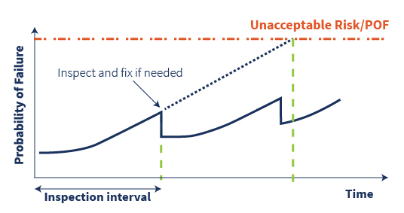

The chief reason for implementing an RBI program is to help manage the risk of a complex and potentially dangerous system.

RBI, when implemented and maintained properly, improves plant reliability and safety while reducing unplanned outages and repair costs.

RBI helps companies:

* select cost effective and appropriate maintenance and inspection tasks and techniques
* shift from a reactive to a proactive maintenance regime
* produce an auditable system

The key is to focus resources on the 10 to 15% of the assets that are driving the bulk of the risk. Generally RBI requires 50% to 90% fewer inspection points than a traditional API inspection program while reducing the risk of failures by 80% to 95%.

|  |  |
| --- | --- |
|  | C:\Users\108066\Desktop\ChartImgG14MR2HF.png |

**The RBI Process**

Risk based inspection is the process of developing inspection strategies based on knowledge of the risk of failure. This is the combination of an assessment of the probability of failure due to flaws, damage, deterioration or degradation with an assessment of the consequences of such failure.

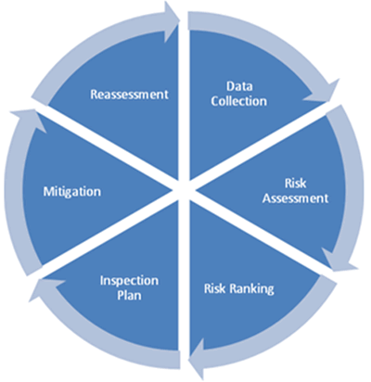

The information gained from this process is used to identify

(a) the type of damage that may potentially be present,

(b) where such damage could occur,

(c) the rate at which such damage might evolve, and

(d) where failure would give rise to danger.

Out come of RBI study is criticality ranking of each asset leading to development of an effective inspection strategy.

Data Collection & Corrosion Study

Development of Inspection Strategies

Carryout Inspection

INSPECTION REPORT

Integrity Operating Window

(IOW)

EVERGREENING

Risk assessment

Item Selection from PFD’s

Update Inspection DATA BASE & Inspection Programs

**Inspection management system**

In inspection management system all the asset related history and related information is stored and information and statics are provided to the user through dash-board for taking effective informed decisions.

It also provides the monitoring of Integrity operating windows (Monitoring of Key process parameters) and Key performance indicators related asset integrity.

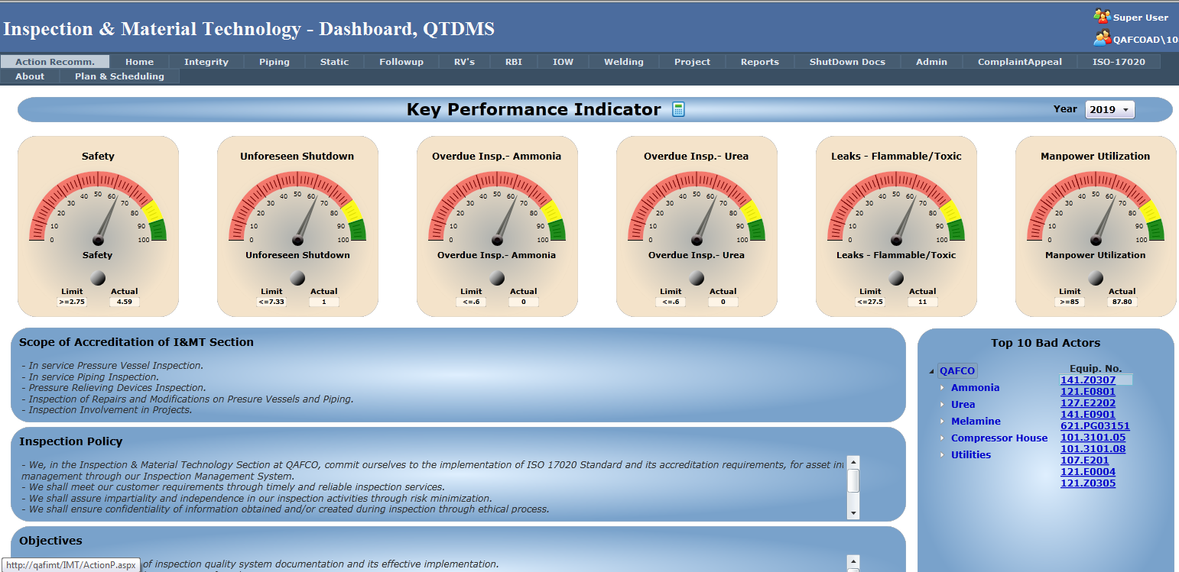

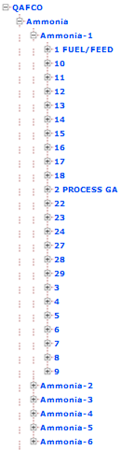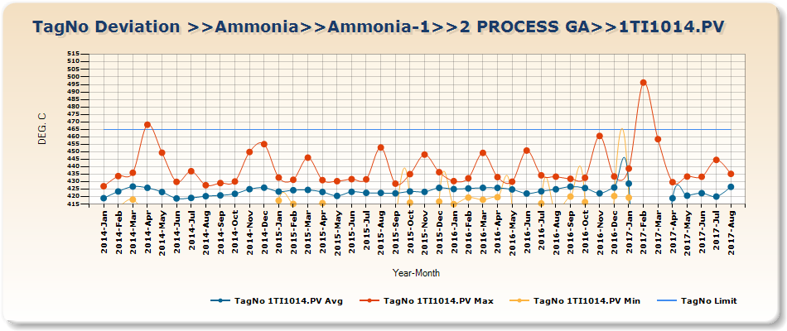

Monitoring the Integrity Operating Window

**Quality control management system**

Quality control system is the supporting management system for an effective asset integrity management system which comprises modules like

* NDE inspections
* Project Quality control systems of new equipmentsetc

**Piping Module**

**Front end Architecture**

**The basic structure of the proposed systems**

Piping is one of the module in the proposed system.

The front end of the system can be divided into 4 elements namely

* Top menu: which is tabbed with different modules like piping, pressure vessels, PRDs etc
* Left side menu: which is navigation menu with drill down options from plant to individual equipment
* Right side menu: which filters out and shows all the related documents of the equipment based on selection from left menu
* Middle display part: which shows the overall statistics at the plant level and the master data if drilled down from plant to equipment.

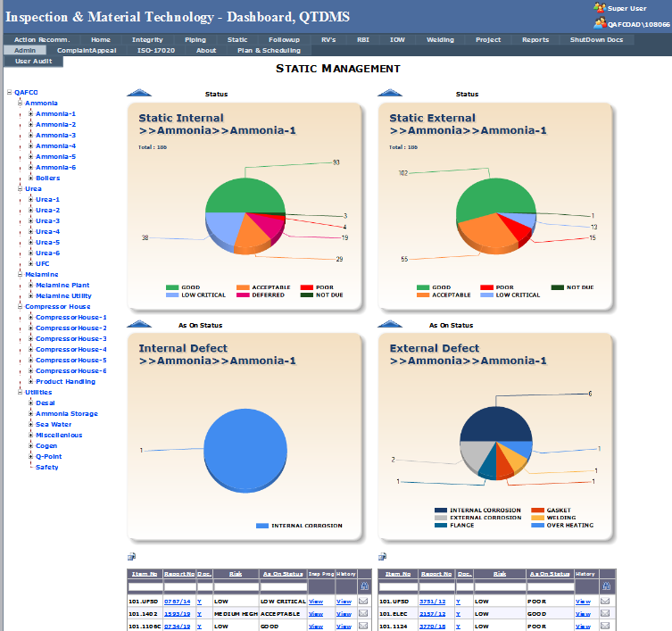

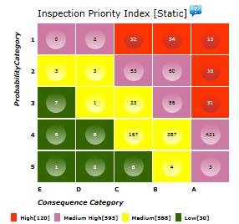

**Top Module menu:**

Top menu has tabs for different modules namely

* Static Equipment
* Piping
* Storage Tanks
* Pressure Relieving devices
* Home with configurable KIPs
* Reports
* Action Followup
* Integrity management statistics
* IOWs
* Project Management
* Welding Quality control

**Navigation Left Menu:**

This is user defined navigation menu of the hierarchy of the site and plants upto to the equipment number. This menu is same for all modules based on user requirement.

The snapshot of the same is shown in following figure.

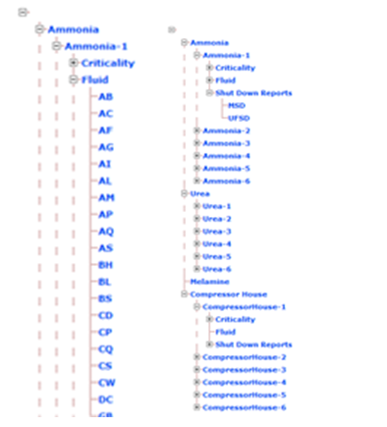

**Navigation Left Menu**

**Related documents Right Menu:**

All related documents and records of the selected equipment based on left menu are filtered and displayed in this menu as collapsible menu.

The ‘Right-side Menu’ or the ‘Quick-Link’ shall be configurable. The link configuration shall be between columns of source and destination tables. i.e., for instance the equipment no of the source table piping master shall be linking with the equip. no column of the destination table. Based on the relationship of the tables, there shall be a display column from the destination table which will be shown on the right-side menu / quick-link. The right-side menu or the quick-link shall show all the linked relationships based on the selected equipment displayed in the central display area.

For example, when a line number is selected on left menu, the following records related to this line will be filtered and shown in right side menu

* Piping reports
* POF master records
* COF master records
* IOW records
* Project records
* Repair Procedure records etc

If any of the displayed records are clicked, then the form related to that document to be opened in the center display area as additional tab.

**1. When a plant or area selected on the left side menu**

The display can be divided into 3 segments top, middle and below

The top display shows 2 graphs as shown below related to selected area of the plant

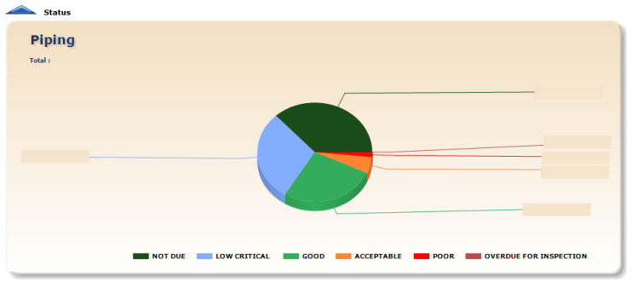**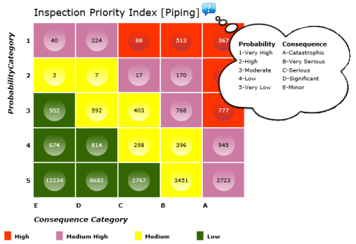Fig: Piping Status Fig: Risk Based Inspection (RBI)**

The middle display shows the following 2 graphs related to selected area of the plant

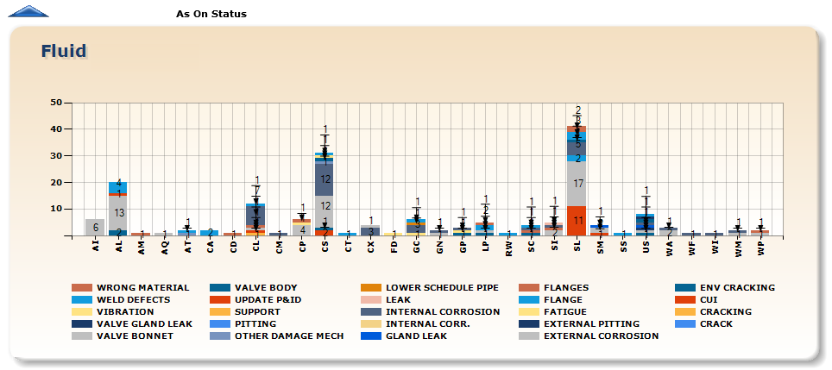

**Fig: Defect Vs Fluid (Based on as on Status)**

Bottom area displays a table of all the pipe lines related to selected area on left menu.

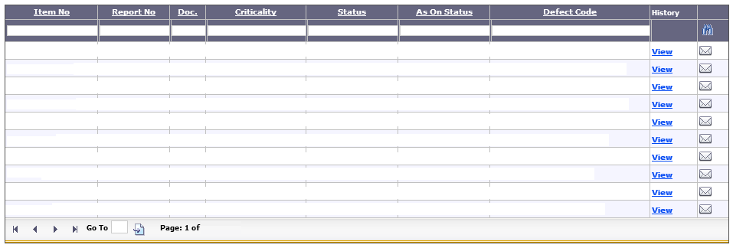

**Fig: Piping Spreadsheet**

By clicking on the line number all history (piping reports) can be opened.

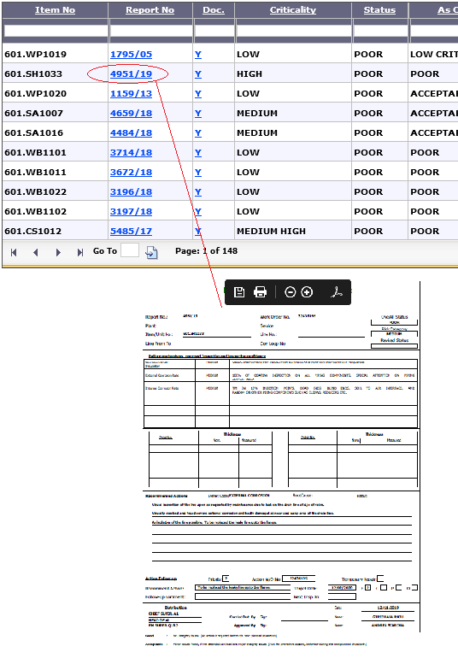

**Fig: Piping Report**

**2. When a Line number is selected on the left side menu**

The display area opens the Piping master form of that line while right menu displays all the related documents of that pipe line. By clicking the related documents on the right menu, the related form will be displayed on the central display area as new tab as shown in the below prototype related to piping.

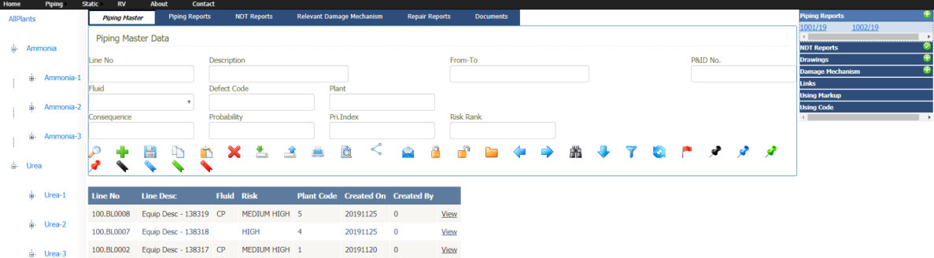

**Fig: Prototype - Piping**

**Tables**

1. **Plant Master**

The plant master is used to configure the Plants in the ‘Navigation Left Menu’. There shall be the following columns as given below. The plant for instance ‘Ammonia-1’ menu created as a child menu linked to the parent menu ‘Ammonia’. This navigation left menu shall be configurable based on the Top Menu

|  |  |  |  |  |
| --- | --- | --- | --- | --- |
| **Table Name** | **Plant Master** | | | |
| **Column Name** | **Data Type** | **Nullable** | **Constraints** | **Comments** |
| Plant ID | NUMBER | No | Primary Key | Used Internal Plant Identification ID for Parent Child Menu Linking |
| Plant Code | CHAR(10) | No | Unique | Used Internal Plant Identification Code |
| Plant Name | CHAR(100) | No |  |  |
| Plant Parent ID | NUMBER | No |  | Used to link the Parent Plant Menu |

1. **User Role Master**

The users with respect to the roles and actions related to the menu shall be configured in this master. For instance User ‘A’ having assigned Role as ‘Role-A’ for which the role is configured with a set of menu along with its pre-defined actions i.e., ‘Edit’, ‘Add’, ‘View’, ‘Search’ etc.

1. **Menu Master \ Top Menu**

The menus related to the top menu along with the associated page actions are configured in this master.

1. **Navigation Left Menu**

The navigation left menu shall be configured based on the top menu. It shall be configurable based on the plant master and the menu based master. For instance, the plant along with the fluid or line no’s related to piping module if piping menu is displayed. If static, the plant along with the equip no’s is populated.

1. **Reports Master**

This table shall have the user defined reports which are configured. There shall be option for design the reports by the end-user or try to access the pre-configured reports based on the user-roles of the end-user.

1. **Plant Distribution Master**

The emails and related details related to respective plants shall be configured in the plant distribution master.

1. **Email Alerts**

The email alert or schedule shall be configurable in this table. There also shall be linked with the plant distribution master list. The output data of the emails can be either form the configured reports based on the parameters or with respect to the pre-defined sql-queries / views related to the input parameters. The input parameters also can be pulldown option linked to any master table e.g., plant codes form plant master, line nos or fluids from piping master etc.

1. **Right Menu \ Quick Links**

The relationship or links mapped shall be configured based on the user roles. The relationship names related to the associated master data of the central display area shall be populated on the right side of the webpage.

|  |  |  |  |  |
| --- | --- | --- | --- | --- |
| **Table Name** | **Quick Link Master** | | | |
| **Column Name** | **Data Type** | **Nullable** | **Constraints** | **Comments** |
| Quick Link ID | NUMBER | No | Primary Key | Used Internal to identify the relation between the source and destination tables |
| Quick link Name | CHAR(100) | No | Unique | Used to display on the header title of the right side menu as well as the tab headers. |
| Source Table | CHAR(100) | No |  | Source table name of the relationship |
| Source Table Column | CHAR(150) | No |  | Column name of the source table relationship |
| Destination Table | CHAR(100) | No |  | Destination table name of the relationship |
| Destination Table Column | CHAR(150) | No |  | Column name of the Destination table relationship |
| Plant Parent ID | NUMBER | No |  | Used to link the Parent Plant Menu |

**Points for Consideration**

1. **Documents**

The documents / reports attached against each table/ module can be either using database or through file system available on the network or on a cloud. This option shall be configurable.

1. **Cloud / Standalone based Architecture**

The web application shall be configurable to work either on an internet network based cloud driven or through the intranet network based server architecture.

1. **SAP / ERP Interface for Handshake**

The web application shall have configurable option to configure with the handshake of master and transactional data.

1. **Web Application Handshake for other Web Apps**

The web application shall have configurable option to configure with other web application through their interfaces. For instance exchange of Man-hour time entry transaction data to other web application through their external interfaces.